DBMS MINI PROJECT REPORT FORMAT

TITLE : TEMPLE RUN GAME DATABASE

- Description on the Project (1 Page)
- Objectives of the Project
- E-R Diagram
- Queries in the order
- Creation of Tables
- Inserting Values into Tables
- Queries (10 Simple + 10 Complex)
For Every Query, Explain the concept in 1or 2 Sentences.
Ex: What is Inner Join ? When we will go for Joins.
Snapshot of the result.

1. Create a database including appropriate entity and attributes for Temple run game .

DROP DATABASE Game_Temple_Run;
CREATE DATABASE Game_Temple_Run;
use Game_Temple_Run
CREATE TABLE User_details
(user_name varchar(20) not null ,
user_id int not null primary key,
sex char(1),
email_id varchar(25) ,
date_logged date);

CREATE TABLE Score_details
(name varchar(20) references User_details(user_name),
user_id int references User_details(user_id),
character_name varchar(15) references Game_character(name),
map_name varchar(20) references Game_map(map_name),
rank int ,
no_of_coins int ,
no_of_gems int ,
highest_score int ,
total_distance int,
no_of_days_spent int );

CREATE TABLE Game_character
(name varchar(15) ,
sex char(1),
outfit varchar(20) ,
hat_type varchar(20) ,
special_ability varchar(20) primary key);

CREATE TABLE Game_map
(map_name varchar(20) primary key,
map_level char(20));

CREATE TABLE Objectives
(user_id int references User_details(user_id),
name varchar(20) references User_details(user_name),
map_name varchar(20) references Game_map(map_name),
no_of_obje_comp int ) ;

CREATE TABLE Rewards
(user_id int references User_details(user_id),
name varchar(20) references User_details(user_name),
map_name varchar(20) references Game_map(map_name),
no_of_artifacts int,
no_of_hats int);

2. Fill the database with some suitable data.

use Game_Temple_Run
DELETE FROM User_details;
INSERT INTO User_details VALUES ('Robert',560078,'M','Robert@gmail.com','01/01/12') ;
INSERT INTO User_details VALUES ('Chris',560079,'M','Chris@gmail.com','01/01/23') ;
INSERT INTO User_details VALUES ('Henry',560080,'M','Henry@gmail.com','01/01/22') ;
INSERT INTO User_details VALUES ('David',560081,'M','David@gmail.com','01/01/07') ;
INSERT INTO User_details VALUES ('Penny',560082,'F','Penny@gmail.com','01/01/08') ;
INSERT INTO User_details VALUES ('Romanoff',560083,'F','Romanoff@gmail.com','01/01/06') ;
INSERT INTO User_details VALUES ('Mrs Paul',560084,'F','Mrs_Paul@gmail.com','01/01/31') ;
INSERT INTO User_details VALUES ('Selina',560085,'F','Selina@gmail.com','01/01/29') ;
INSERT INTO User_details VALUES ('Alisa',560086,'F','Alisa@gmail.com','01/01/15') ;
INSERT INTO User_details VALUES ('Scarlett',560087,'F','Scarlett@gmail.com','01/01/17') ;

DELETE FROM Score_details ;
INSERT INTO Score_details VALUES ('Robert',560078,'Guy Dangerous','JungleFall',1,9800,9,400000,950,12) ;
INSERT INTO Score_details VALUES ('Robert',560078,'Barry Bones','Spirits Cove',5,7700,4,451000,750,12) ;
INSERT INTO Score_details VALUES ('Robert',560078,'Zack Wonder','Volcano Fall',4,6600,6,308900,860,12) ;
INSERT INTO Score_details VALUES ('Chris',560079,'King Fafnir','Blazing Sands', 9,1500,1,39000, 100,1) ;
INSERT INTO Score_details VALUES ('Chris',560079,'Santa', 'Blazing Sands', 4,8500,6,59000, 700,1) ;
INSERT INTO Score_details VALUES ('Henry',560080,'Maria Selva','Pirate Cove', 2,4500,2,70000,850,9) ;
INSERT INTO Score_details VALUES('Henry',560080,'GuyDangerous','FrozenShadows',7,1500,0,20000,350,9);
INSERT INTO Score_details VALUES ('Henry',560080,'Barry Bones','Blooming Sands',5,1500,1,15000,250,9) ;
INSERT INTO Score_details VALUES ('Henry',560080,'Zack Wonder','Sky Summit', 9,500,0,1000,50,9) ;
INSERT INTO Score_details VALUES ('David',560081,'Zack Wonder','Sky Summit', 3,5600,5,55000,750,8) ;
INSERT INTO Score_details VALUES ('Penny',560082,'Scarlett Fox','Winter Wastelands', 7,1500,2,54000,210,6) ;
INSERT INTO Score_details VALUES ('Penny',560082,'Queen Astrid','Frozen Shadows', 6,1000,0,14000,110,6) ;
INSERT INTO Score_details VALUES ('Romanoff',560083,'Karma Lee' ,'Pirate Cove',8,1400,3,90000,110,2) ;
INSERT INTO Score_details VALUES ('Romanoff',560083,'Maria Selva' ,'Blooming Sands',2,9400,6,99000,990,2) ;
INSERT INTO Score_details VALUES ('Romanoff',560083,'Zack Wonder' ,'Winter Wastelands',10,40,0,900,10,2) ;
INSERT INTO Score_details VALUES ('Mrs Paul',560084,'Scarlett Fox','Winter Wastelands',6,1900,4,830000,380,3) ;
INSERT INTO Score_details VALUES ('Selina',560085,'King Fafnir','Volcano Fall',5,2500,6,840000,540,5) ;
INSERT INTO Score_details VALUES ('Selina',560085,'Santa','Volcano Fall',8,500,1,110000,140,5) ;
INSERT INTO Score_details VALUES ('Alisa',560086,'Scarlett Fox','Spirits Cove',4,4500,7,890000,640,7) ;
INSERT INTO Score_details VALUES ('Alisa',560086,'Queen Astrid','Blazing Sands',1,9500,8,990000,940,7) ;
INSERT INTO Score_details VALUES ('Alisa',560086,'Maria Selva','Sky Summit',1,9050,10,990000,964,7) ;
INSERT INTO Score_details VALUES ('Scarlett',560087,'Scarlett Fox','Sky Summit',10,1300,0,14000,50,1) ;
INSERT INTO Score_details VALUES ('Scarlett',560087,'Karma Lee','Blooming Sands',1,9300,10,94000,950,1) ;
INSERT INTO Score_details VALUES ('Scarlett',560087,'Mrs Claus','Jungle Fall',10,300,0,10000,40,1) ;
INSERT INTO Score_details VALUES ('Scarlett',560087,'Maria Selva','Volcano Fall',10,1100,0,11000,60,1) ;

DELETE FROM Game_character ;
INSERT INTO Game_character VALUES ('Guy Dangerous', 'M', 'Aviator','Jade Demon MASK', 'Fast Runner') ;
INSERT INTO Game_character VALUES ('Scarlett Fox', 'F', 'Mountaineer','Fire Fighter Helmet', 'Quick Collector') ;
INSERT INTO Game_character VALUES ('Karma Lee', 'F', 'Shadow Walker','Critter Hat', 'Narrow Escaper') ;
INSERT INTO Game_character VALUES ('Barry Bones', 'M', 'Outrider','Floral Hat', 'Good Health') ;
INSERT INTO Game_character VALUES ('Santa', 'M', 'Volcanic','Arctic Hat', 'High Shield Duration') ;
INSERT INTO Game_character VALUES ('Mrs Claus', 'F', 'Magnum','Frozen Shawdows Helm', 'Good Pickup') ;
INSERT INTO Game_character VALUES ('King Fafnir', 'M', 'Franken Guy','Essence Of Deer', 'Score Multiplier');
INSERT INTO Game_character VALUES ('Queen Astrid', 'F', 'Regal','Shadow Horns', 'Boost Powerup') ;
INSERT INTO Game_character VALUES ('Maria Selva', 'F', 'Brooklyn','Anubis Head Piece', 'Coin Bonus') ;
INSERT INTO Game_character VALUES ('Zack Wonder', 'M', 'Romeo','Jungle Thinking Cap', 'Gem Bonus') ;

DELETE FROM Game_map ;
INSERT INTO Game_map VALUES ('Sky Summit' ,'Easy') ;
INSERT INTO Game_map VALUES ('Frozen Shadows' ,'Easy') ;
INSERT INTO Game_map VALUES ('Blazing Sands' ,'Easy') ;
INSERT INTO Game_map VALUES ('Pirate Cove' ,'Moderate') ;
INSERT INTO Game_map VALUES ('Spirits Cove' ,'Moderate') ;
INSERT INTO Game_map VALUES ('Jungle Fall' ,'Moderate') ;
INSERT INTO Game_map VALUES ('Blooming Sands' ,'Difficult') ;
INSERT INTO Game_map VALUES ('Winter Wastelands' ,'Difficult') ;
INSERT INTO Game_map VALUES ('Volcano Fall' ,'Difficult') ;

DELETE from Objectives ;
INSERT INTO Objectives VALUES (560078,'Robert','Sky Summit',10) ;
INSERT INTO Objectives VALUES (560078,'Robert','Frozen Shadows',5) ;
INSERT INTO Objectives VALUES (560078,'Robert','Volcano Fall',1) ;
INSERT INTO Objectives VALUES (560079,'Chris','Sky Summit',5) ;
INSERT INTO Objectives VALUES (560079,'Chris','Frozen Shadows',4) ;
INSERT INTO Objectives VALUES (560080,'Henry','Blazing Sands',7) ;
INSERT INTO Objectives VALUES (560080,'Henry','Pirate Cove',2) ;
INSERT INTO Objectives VALUES (560081,'David','Spirits Cove',4) ;
INSERT INTO Objectives VALUES (560081,'David','Jungle Fall',3) ;
INSERT INTO Objectives VALUES (560081,'David','Blooming Sands',9) ;
INSERT INTO Objectives VALUES (560082,'Penny','Sky Summit',8) ;
INSERT INTO Objectives VALUES (560082,'Penny','Winter Wateland',7) ;
INSERT INTO Objectives VALUES (560082,'Penny','Volcano Fall',10) ;
INSERT INTO Objectives VALUES (560083,'Romanoff','Sky Summit',4) ;
INSERT INTO Objectives VALUES (560083,'Romanoff','Frozen Shadows',6) ;
INSERT INTO Objectives VALUES (560083,'Romanoff','Blazing Sands',7) ;
INSERT INTO Objectives VALUES (560084,'Mrs Paul','Pirate Cove',5) ;
INSERT INTO Objectives VALUES (560084,'Mrs Paul','Spirits Cove',8) ;
INSERT INTO Objectives VALUES (560085,'Selina','Jungle Fall',9) ;
INSERT INTO Objectives VALUES (560085,'Selina','Blooming Sands',0) ;
INSERT INTO Objectives VALUES (560086,'Alisa','Sky Summit',6) ;
INSERT INTO Objectives VALUES (560087,'Scarlett','Volcano Fall',1) ;
INSERT INTO Objectives VALUES (560087,'Scarlett','Sky Summit',2) ;

DELETE from Rewards ;
INSERT INTO Rewards VALUES (560078,'Robert','Sky Summit',9,5) ;
INSERT INTO Rewards VALUES (560078,'Robert','Frozen Shadows',7,2) ;
INSERT INTO Rewards VALUES (560078,'Robert','Volcano Fall',2,4) ;
INSERT INTO Rewards VALUES (560079,'Chris','Sky Summit',2,1) ;
INSERT INTO Rewards VALUES (560079,'Chris','Frozen Shadows',9,6) ;
INSERT INTO Rewards VALUES (560080,'Henry','Blazing Sands',4,7) ;
INSERT INTO Rewards VALUES (560080,'Henry','Pirate Cove',2,0) ;
INSERT INTO Rewards VALUES (560081,'David','Spirits Cove',7,4) ;
INSERT INTO Rewards VALUES (560081,'David','Jungle Fall',3,3) ;
INSERT INTO Rewards VALUES (560081,'David','Blooming Sands',9,0) ;
INSERT INTO Rewards VALUES (560082,'Penny','Sky Summit',0,8) ;
INSERT INTO Rewards VALUES (560082,'Penny','Winter Wateland',6,7) ;
INSERT INTO Rewards VALUES (560082,'Penny','Volcano Fall',1,0) ;
INSERT INTO Rewards VALUES (560083,'Romanoff','Sky Summit',7,4) ;
INSERT INTO Rewards VALUES (560083,'Romanoff','Frozen Shadows',6,5) ;
INSERT INTO Rewards VALUES (560083,'Romanoff','Blazing Sands',7,3) ;
INSERT INTO Rewards VALUES (560084,'Mrs Paul','Pirate Cove',5,4) ;
INSERT INTO Rewards VALUES (560084,'Mrs Paul','Spirits Cove',0,8) ;
INSERT INTO Rewards VALUES (560085,'Selina','Jungle Fall',9,0) ;
INSERT INTO Rewards VALUES (560085,'Selina','Blooming Sands',1,2) ;
INSERT INTO Rewards VALUES (560086,'Alisa','Sky Summit',6,3) ;
INSERT INTO Rewards VALUES (560087,'Scarlett','Volcano Fall',1,5) ;
INSERT INTO Rewards VALUES (560087,'Scarlett','Sky Summit',2,4) ;

3. Put the appropriate screenshots .

Database → Game_Temple_Run

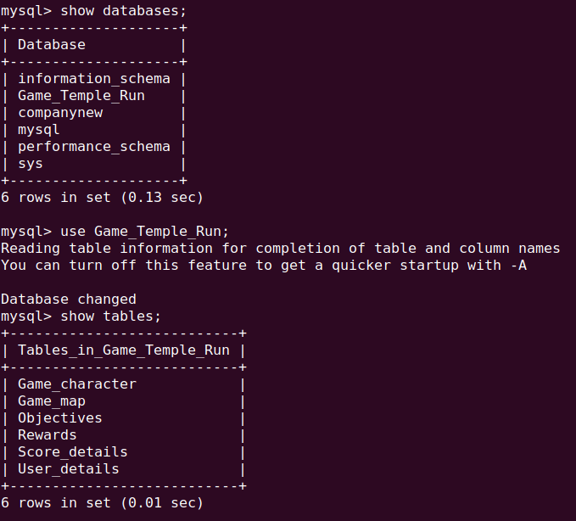

Game_characters details:

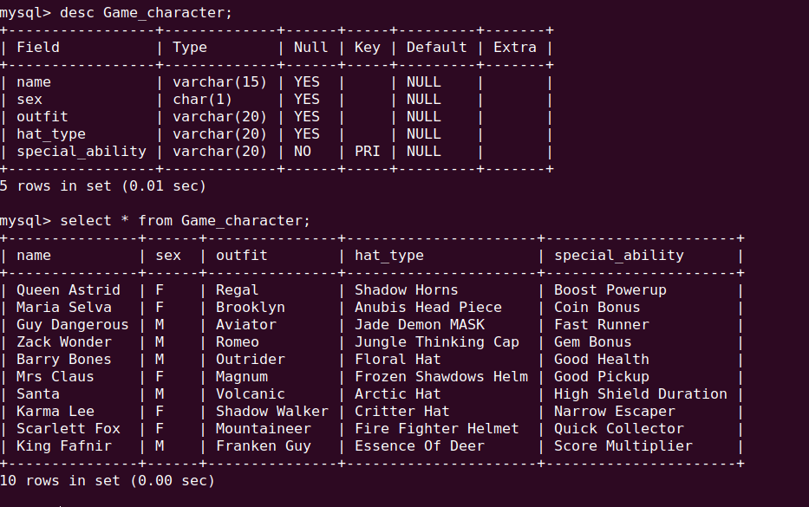
Game_map_details :

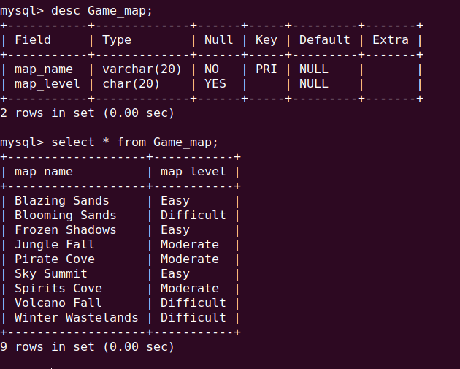

Objectives :

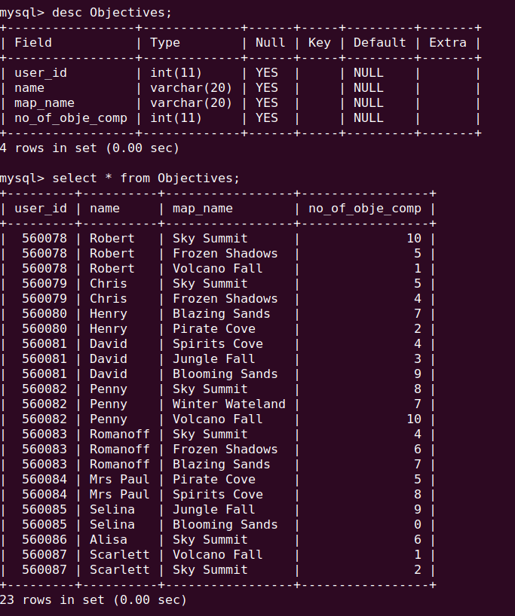

Rewards :

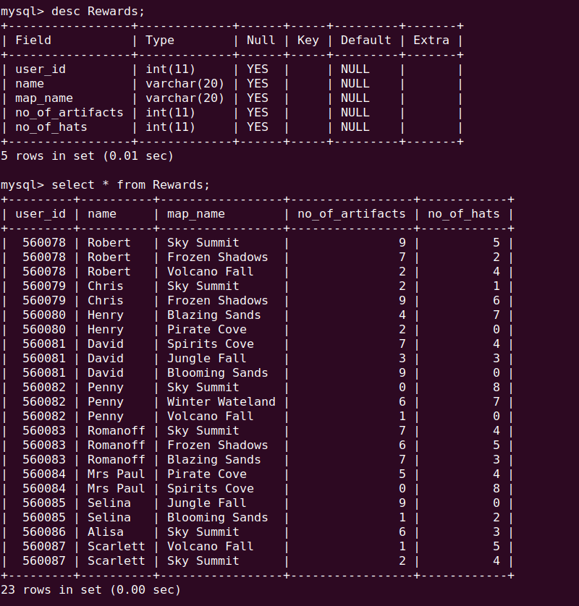

User_details :

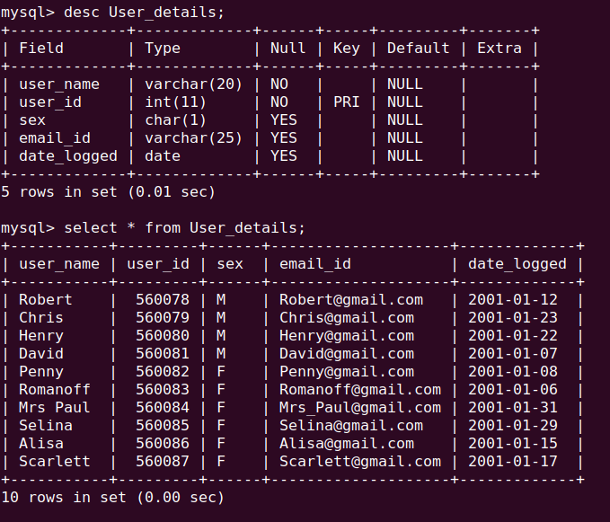

Score_details:

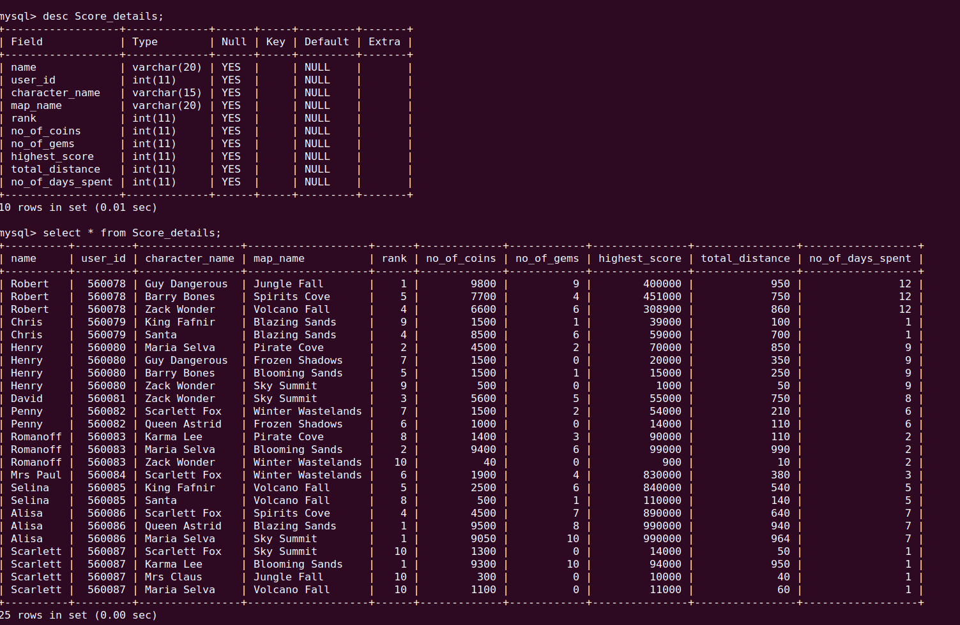

4. Create 10 simple queries for the database .

1. Find the names of character played by Robert .

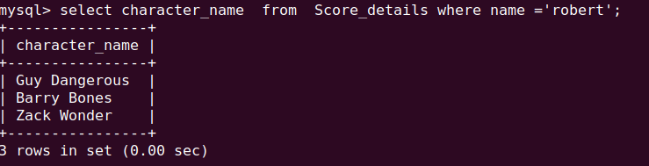

2. Find the names of all player using the character Maria Selva .
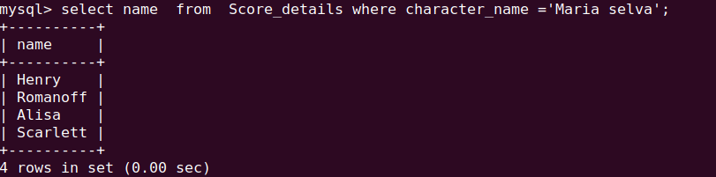

3. Find the names of player having gems > 5 .
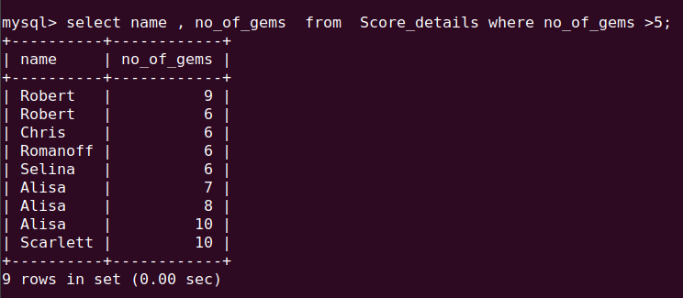
4. Find the names of player who has score greater than 930000 .
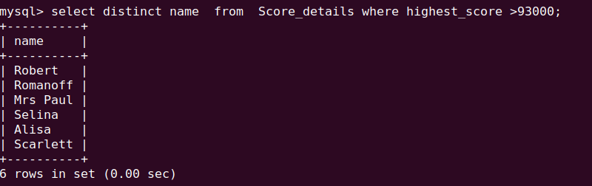
5. Find the names of player having logged in before 20 January 2001 .

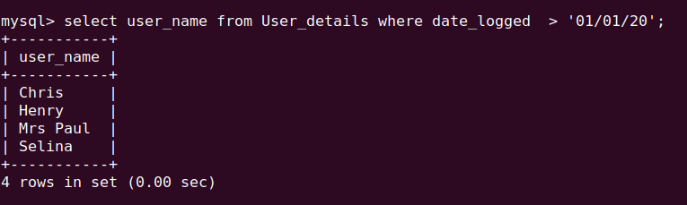

6. Find the name of all players having “r” in their names .

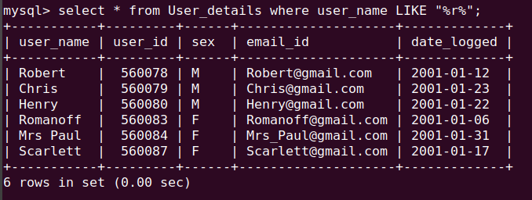

7. Find the player who has achieved more than 5 artifacts and 6 hats .

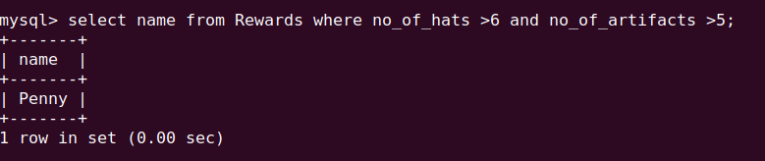
8. Find the name of all player who has completed 5 objectives in map Blooming sands .

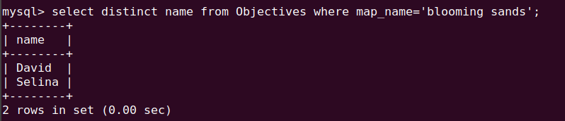
9. list all the map name with level as moderate.

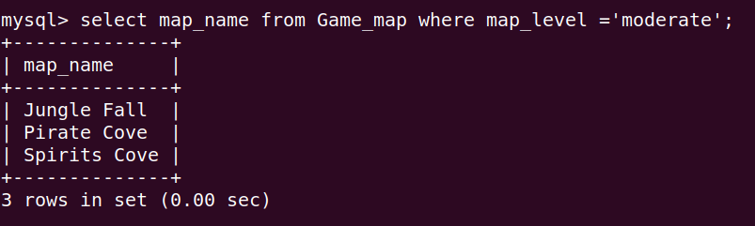

10. Find the names of male player who has spent more than 10 days in playing .

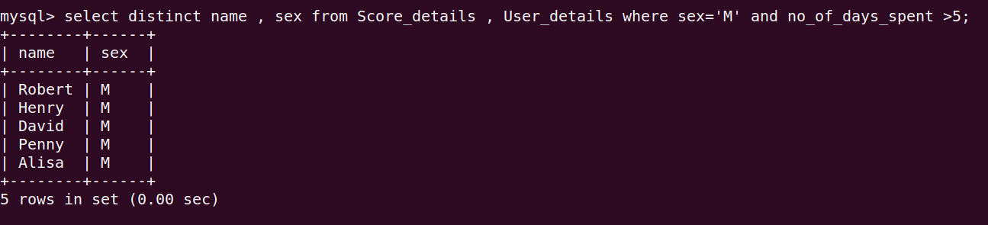

5. Create 10 complex query for the databases .

1.Mark the player as noob if the rank is 10 else remark as good .

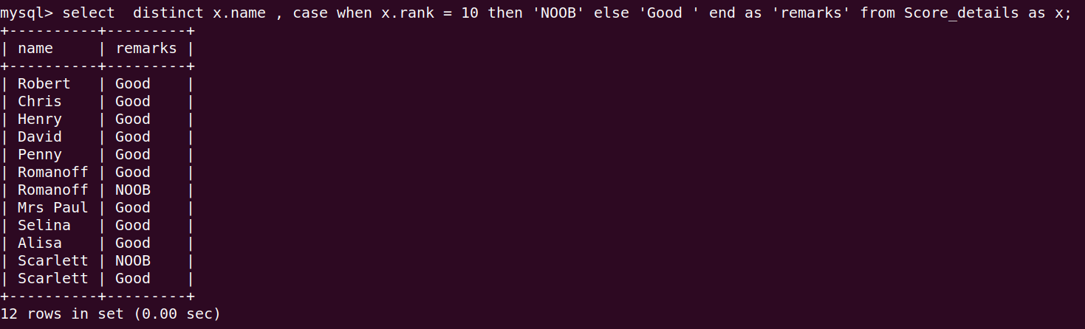
This query is regarding remark statement.

2. Find the 2nd highest scorer in the game .

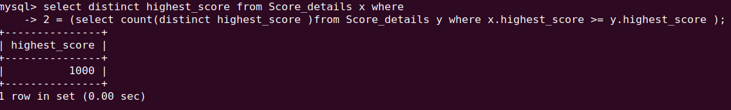

This query is regarding nesting select .

3. Find the number of person ranked 1.

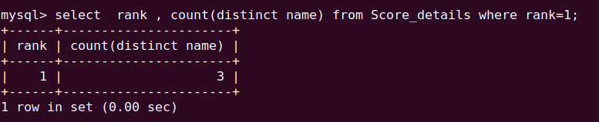
This query is regarding count .

4. Find the highest score of each player.

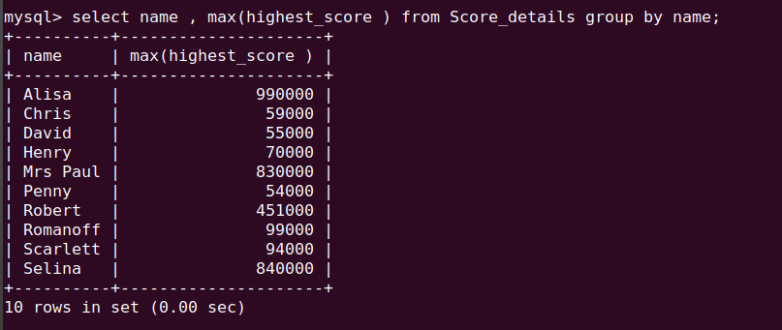
This query is regarding max function.

5. Find the total no of coins achieved by Scarlett .

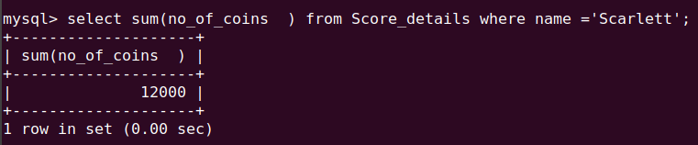
This query is regarding sum function.

6. Create a view which show map name with map level as easy .

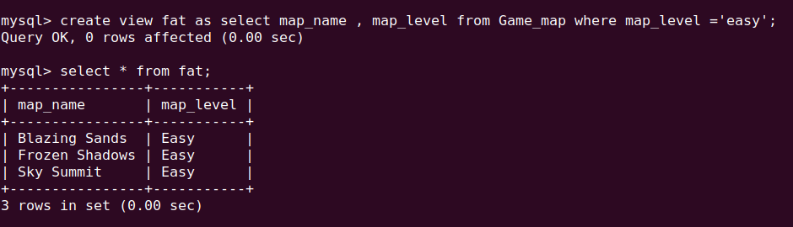
This query is regarding creating and displaying view .

7. list all the players who have played difficult level in map .

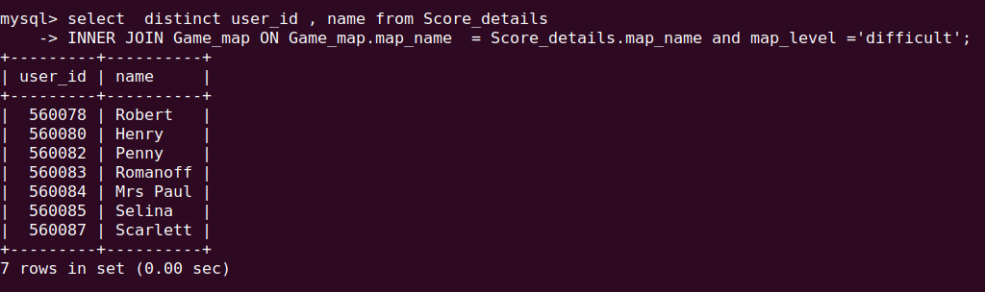
This query is regarding inner joins.

